**A**

**Project Report**

**On**

**“Dry and Wet Garbage Separator”**

**SUBMITTED FOR PARTIAL FULFILLMENT FOR THE AWARD OF**

**DIPLOMA IN**

**COMPUTER ENGINEERING**

**SUBMITTED BY**

**Student Name Seat No.**

**Ms. Ritika. R. Adam**

**Ms. Shreya . R. Arlimar**

**Ms. Shruti. D. Bhosale**

**Ms. Pratiksha. K. Katap**

**UNDER THE GUIDANCE**

**Ms. Tambake. T. R**



**DERARTMENT OF COMPUTER ENGINEERING**

**SHRI SIDDHESHWAR WOMENS POLYTECHNIC,**

**SOLAPUR – 413002**

**2019-20**

**SHRI SIDDHESHWAR WOMEN’S POLYTECHNIC,**

**SOLAPUR**



**CERTIFICATE**

This is to certify that the final year project work for the subject **Capstone Project** entitled **“Dry and Wet Garbage Separator”** is a bonafied work carried out in partial fulfillment for the award of diploma in Computer Engineering Department during 2019-20

**Student Name Roll No. Exam Seat No.**

**Ms. Laxmi. Kapare 3219**

**Ms. Pratiksha. Katap 3220**

**Ms. Ayushri. Lahoti 3226**

**Ms. Manjula. Mitti 3229**

**Ms. Tambake. T.R Ms. Zipare. M.M Prof. Dharane G.R.**

Course Co-coordinator Head Comp. Engg. Dept. Principal

**CERTIFICATE**

This is to certify Ms. Ritika. R. Adam from Shri Siddheshwar women’s polytechnic solapur College having Enrollment no. 1712260050 has completed Report on the Defination/semester VI Project Report/ ***Final Project report*** having title “Dry and Wet Garbage Separator” in a group consisting of 4 person under the guidance of the Faculty Guide.

The mentor from industry for the project

Name: Mr. Siddheshwar Tengle

Telephone: 9850800079

**CERTIFICATE**

This is to certify Ms. Shreya . R. Arlimarfrom Shri Siddheshwar women’s polytechnic solapur College having Enrollment no. 1712260053 has completed Report on the Defination/semester VI Project Report/ ***Final Project report*** having title “Dry and Wet Garbage Separator” in a group consisting of 4 person under the guidance of the Faculty Guide.

The mentor from industry for the project

Name: Mr. Siddheshwar Tengle

Telephone: 9850800079

**CERTIFICATE**

This is to certify Ms. Shruti. D. Bhosalefrom Shri Siddheshwar women’s polytechnic solapur College having Enrollment no. 1712260055 has completed Report on the Defination/semester VI Project Report/ ***Final Project report*** having title “Dry and Wet Garbage Separator” in a group consisting of 4 person under the guidance of the Faculty Guide.

The mentor from industry for the project

Name: Mr. Siddheshwar Tengle

Telephone: 9850800079

**CERTIFICATE**

This is to certify Ms. Pratiksha. K. Katapfrom Shri Siddheshwar women’s polytechnic solapur College having Enrollment no. 1712260075 has completed Report on the Defination/semester VI Project Report/ ***Final Project report*** having title “Dry and Wet Garbage Separator” in a group consisting of 4 person under the guidance of the Faculty Guide.

The mentor from industry for the project

Name: Mr. Siddheshwar Tengle

Telephone: 9850800079

**ACKNOWLEDGMENT**

It was very exiting for us to work on the project entitled.

Dry and Wet Garbage Separator during this work we have gained both practical as well as theoretical knowledge of great significance.

We are greatly obligated to our respected guide **Ms. Tambake.T.R** for her valuable suggestion and help.

Finally we would like to thanks **Ms. Zipre.M.M** Head of Department of Computer Engineering Department, whose sincere and careful guidance led us to complete the project. We express our deep sense of gratitude to **Prof. G.R.Dharane** our Principal for his constant interest and encouragement throughout the completion of my project.

We also thankful to our parents and friends for their extended support and valuable guidance.

**Ms. Ritika. R. Adam**

**Ms. Shreya . R. Arlimar**

**Ms. Shruti. D. Bhosale**

**Ms. Pratiksha. K. Katap**

**ABSTRACT**

The project entitled “Dry and wet garbage separator” is basically an IoT based system the automatically separates the dry and wet waste. The system simply uses sensors to sense the moisture of the garbage which is dropped into the bin. This system does not require any human instruction to separate out the garbage.

This project is the solution to the modern problem of waste segregation. And the best system which contributes to achieve the goal of smart city where the garbage is separated automatically separated. Where the dustbin automatically open when it sense that someone is trying to drop the waste in it, when the waste is dropped it sense where the waste is dry or wet. Even when the bin is about to fill it intimates the users by some buzzers.

As currently garbage segregation is done manually it is harmful for the human health too as well it is time consuming activity. To save the time and reduce the human efforts this system is the best solution.

**TABLE OF CONTENT**

|  |  |  |
| --- | --- | --- |
| **Chapter no.** | **Chapter Name** | **Page no.** |
| 1. | Introduction | 10 |
| 2. | Literature Survey | 11 |
| 3. | Methodology | 12 |
| 4. | Designing and code | 13 |
| 5. | Result | 17 |
| 6. | Conclusion and future scope | 18 |
|  | Reference and Bibliography | 19 |

**Chapter 1**

**INTRODUCTION**

As we move towards a more digitalized future, it is directly proportional to increase in urbanization and industrialization. This is the main cause of generation of large amount of waste. As per the report published by World Bank, approximately 1.3 billion tones of municipal waste is generated every year and it is expected to rise to approximately 2.2 billion tons per year by 2025. The main goal of the project is to design and develop a sorting system that sorts and waste automatically into two categories namely dry waste, wet waste. When the waste is segregated into basic streams such as wet and dry the waste has a higher potential of recovery, and consequently, recycled and reused. The wet waste fraction is often converted either into compost or methane-gas or both.

This system is useful to segregate the garbage. It’s being developed for achieving solution on one of the most important problem of environment that’s waste management.This system separates the dry and wet waste automatically.It is Ardunio based system. Act as a microcontroller, Arduino Uno is based on the ATmega328. It has 14 digital input/output pins, 6 analog inputs, a 16 MHz quartz crystal, a USB connection, a power jack, and a reset button. The board can be programmed with Arduino Software (IDE). The board can operate on an external supply from 6 to 20 volts. In our system when the user drops the garbage in the bin, firstly the ultrasonic sensor senses if the garbage is dropped. If there is garbage then the water drop sensor checks the moisture. If the moisture is detected then the garbage is dropped in wet bin otherwise is dropped in dry bin.There is sever motor in our project for flipping of disk accordingly when moisture is detected to 0degree i.e. wet bin and when moisture is not detected to 180degree i.e. dry bin. The main sources of waste are industrial and domestic waste.

This project mainly concentrates on domestic waste whose value is unrecognized since people don’t spend time on segregating waste into their basic streams. The wet waste generated can be used to generate biogas, and dry waste can be send for recycling.

**Chapter 2**

**LITERATURE SURVEY**

A trend of significant increase in municipal waste generation has been recorded worldwide. This has been found due to over population growth rate, industrialization, urbanization and economic growth which have ultimately resulted in increased waste generation. Final destination of solid waste in India is disposal. Most urban waste in Indian cities and towns is land filled and dumped. Our Project deals with the most blistering topic i.e. waste segregation. An efficacious management needs to be materialized for better planet to live in. Hence, with our cost effective project proposal, we try to bring in the change.

It deals with the minimization of land degradation for exclusion of dry and wet waste into an automated garbage separation bin. An automation of this style not only saves the manual segregators of the numerous health issues, but also proves to be economical to the nation. Besides, this system utilizes low cost components for the successful segregation of most types of waste. When installed in apartments or small colonies, it proves to be beneficial in sorting the waste at the site of disposal itself.Due to this waste lies littered in the surrounding, dumped on open lands and this becomes major problem for various types of disease causing bacteria and viruses which is why waste management is of vital importance.

Segregation makes it possible to reuse and recycle the waste effectively. So the waste management becomes an important concern for the health and well-being of society. Due to lack of segaration method a large amount of untreated waste is dumped as landfills. So our idea is to make a garbage segregator which can identify the type of waste and put the dry and wet waste in different bins accordingly and automatically. Implementing our project at household level will reduce the expenditure on waste disposal, manual effort required for waste segregation and the waste could be easily being recycled, reused and reduced.

**Chapter 3**

**METHODOLOGY**

Module 1: The bin gets automatically opens when the user tries to put the garbage.

Module 2: The garbage gets automatically separated.

Module 3: The user gets automatically intimated when the bin is full.

Module 1: The bin gets automatically opens when the user tries to put the garbage.

This module uses Ultrasonic sensors and Servo motor. When the user takes his hand above the bin, the ultrasonic sensor senses the distance at which the hand is there. If the distance is less than or equal to a specified distance then the servo motor flips at 180 degree where as it is ideally at 90 degree and bin gets open. After some period of time the servo motor again returns at 90 degree and bin gets closed. And that garbage gets dropped on a shit of water drop sensors.

Module 2: The garbage gets automatically separated.

This module uses Water Drop sensors and Servo motor. In this module the disk of four water drop sensors is placed in such a way that when the user drops garbage it is directly dropped on the disk. If the moisture is detected in the garbage then the servo motor is flipped to 0 degree and the garbage is dropped in the wet bin. And if the moisture is not detected then the servo motor connected to the disk is flipped to the 180 degree that is the garbage is dropped to the dry bin.

Module 3: The user gets automatically intimated when the bin is full.

This module uses ultrasonic sensor and buzzers. In this module both the dry and wet bin are examined. In this the user is intimated with the help of buzzer. The ultrasonic sensors are place above the dry and wet bin and when the distance from the ultrasonic sensor is minimum the buzzer is triggered so that the user understands that the bin is about to fill and he may make the bin empty.

**Chapter 4**

**DESIGN AND CODE**

**Design**

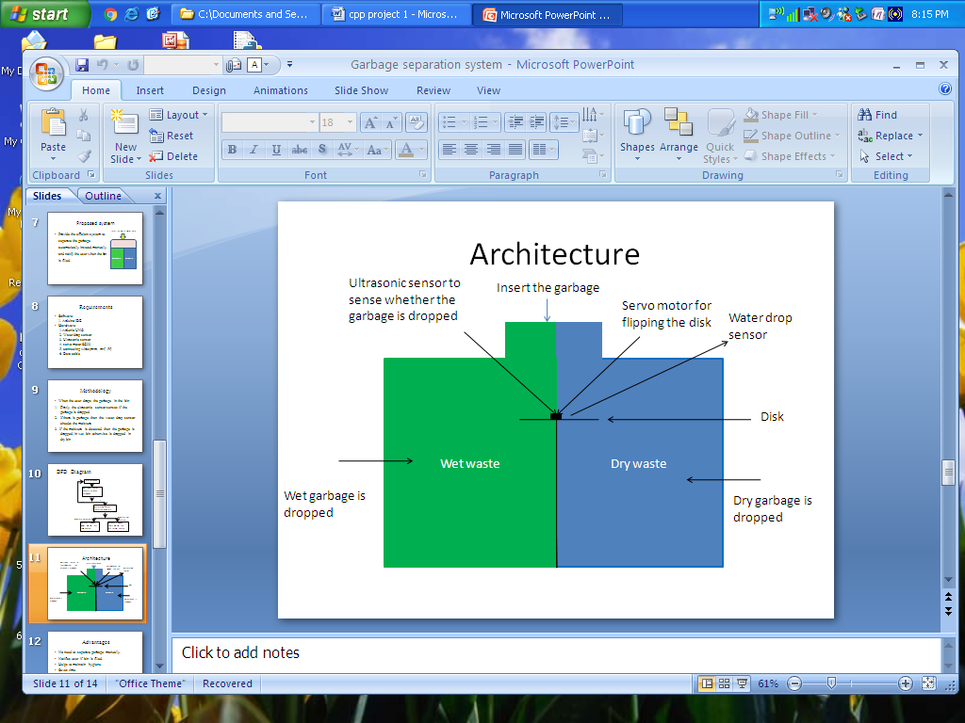

Fig: Design structure of the system

**Code**

#include<Servo.h>

Servo servo;

//int trig_pin1=10;

//int echo_pin1=11;

int S1,S2,S3,S4;

void setup() {

servo.attach(7);

servo.write(90);

S1=0;

S2=0;

S3=0;

S4=0;

Serial.begin(9600);

//pinMode(trig_pin1,OUTPUT);

//pinMode()

}

void loop() {

S1=analogRead(A0);

S2=analogRead(A1);

S3=analogRead(A2);

S4=analogRead(A3);

Serial.print("S1=");

Serial.println(S1);

delay(1000);

Serial.print("S2=");

Serial.println(S2);

delay(1000);

Serial.print("S3=");

Serial.println(S3);

delay(1000);

Serial.print("S4=");

Serial.println(S4);

delay(1000);

if(S1<750 || S2<750 || S3<750 || S4<750)

{

Serial.println("Moisture detected");

servo.write(0);

Serial.println("disk flipped at 0");

delay(2000);

servo.write(90);

Serial.println("disk at 90");

}

else

{

Serial.println("moisture not detected");

servo.write(90);

servo.write(180);

Serial.println("disk flipped at 180");

delay(2000);

servo.write(90);

Serial.println("disk at 90");

}

}

**Chapter 5**

**RESULT**

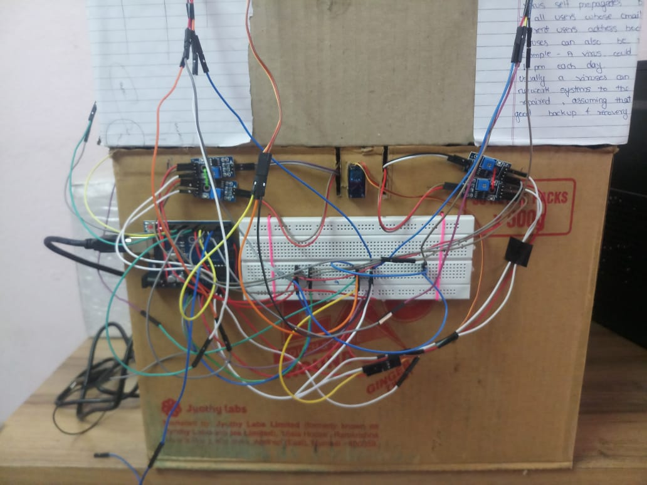

**Chapter 6**

**CONCLUSION AND FUTURE SCOPE.**

**Conclusion**

* Thus we have achieved to separate wet garbage andnotify user after the container is filled.
* This project will help create more resources for recycling as it decreases the probability of contamination, hence increasing the resources usable for recycling.

**Future Scope**

* Every project always has scope for improvement, perhaps the most pressing issue of separation of waste is when their dispose simultaneously. The waste segregator can be improvised to include the separation of paper and plastic, safe segregation of biomedical waste generated at home, compact and aesthetic Mechanical design.
* Solar panel can be used as power supply.
* Provision can be made for on spot decomposition of wet waste.

**REFERENCES AND BIBLIOGRAPHY**

**References**

* [www.researchgate.com](http://www.researchgate.com)
* [www.electronicshubs.org](http://www.electronicshubs.org)
* [www.eadtrust.eu](http://www.eadtrust.eu)

**Bibliography**

* N. N. Ahamad, S. Y. Mohamad, N. S. Midi, S. H. Yusoff, and F. Abd Rahman, “Discrimination of Residual and recyclable waste for automatic waste separation system”.
* Claudine Carpel. Innovations in Waste Management World march 2010.

•Provisions can be made for on spot e

•Solar panels can be used as power supply.

•Solar panels can be used as power supply.

•Solar panels can be used as power supply.